

**EXAM BOOK**

**Grade 2**

School: ________________

Class: _________________

Name: _________________

_______________________

**2**

**ENGLISH**

|  |  |  |  |  |  |  |  |  |
| --- | --- | --- | --- | --- | --- | --- | --- | --- |
| № | E1 | E2 | E3 | E4 | E5 | E6 | E7 | E8 |
| Mark |  |  |  |  |  |  |  |  |



***Date: _______________***

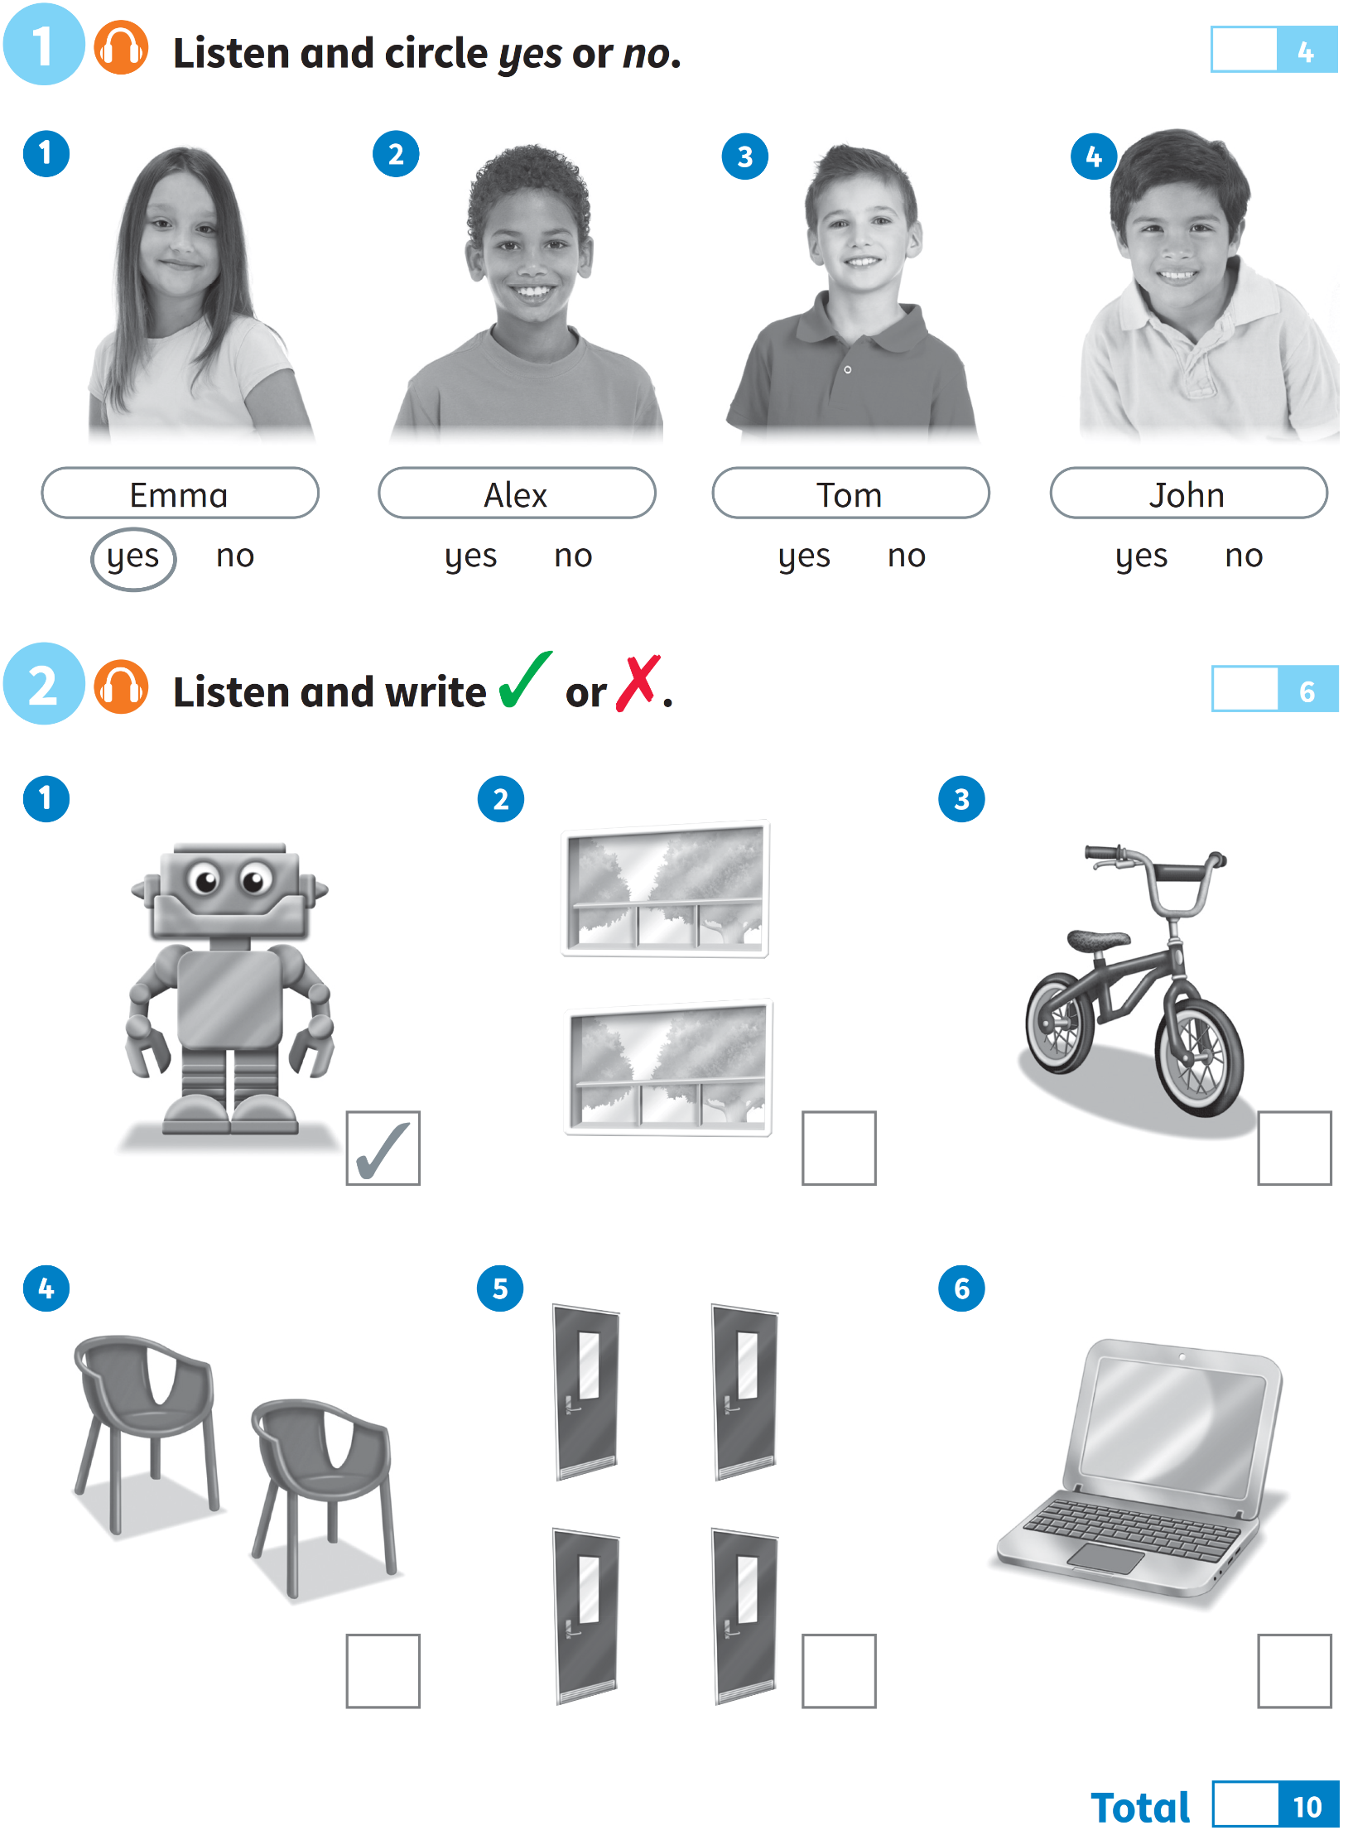**EXAM 1**

**4**

# 6

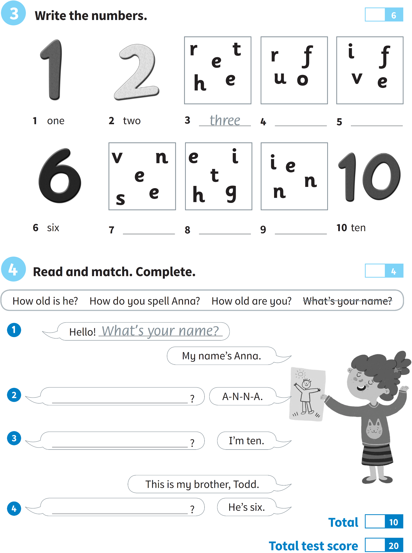

***Date: _______________***

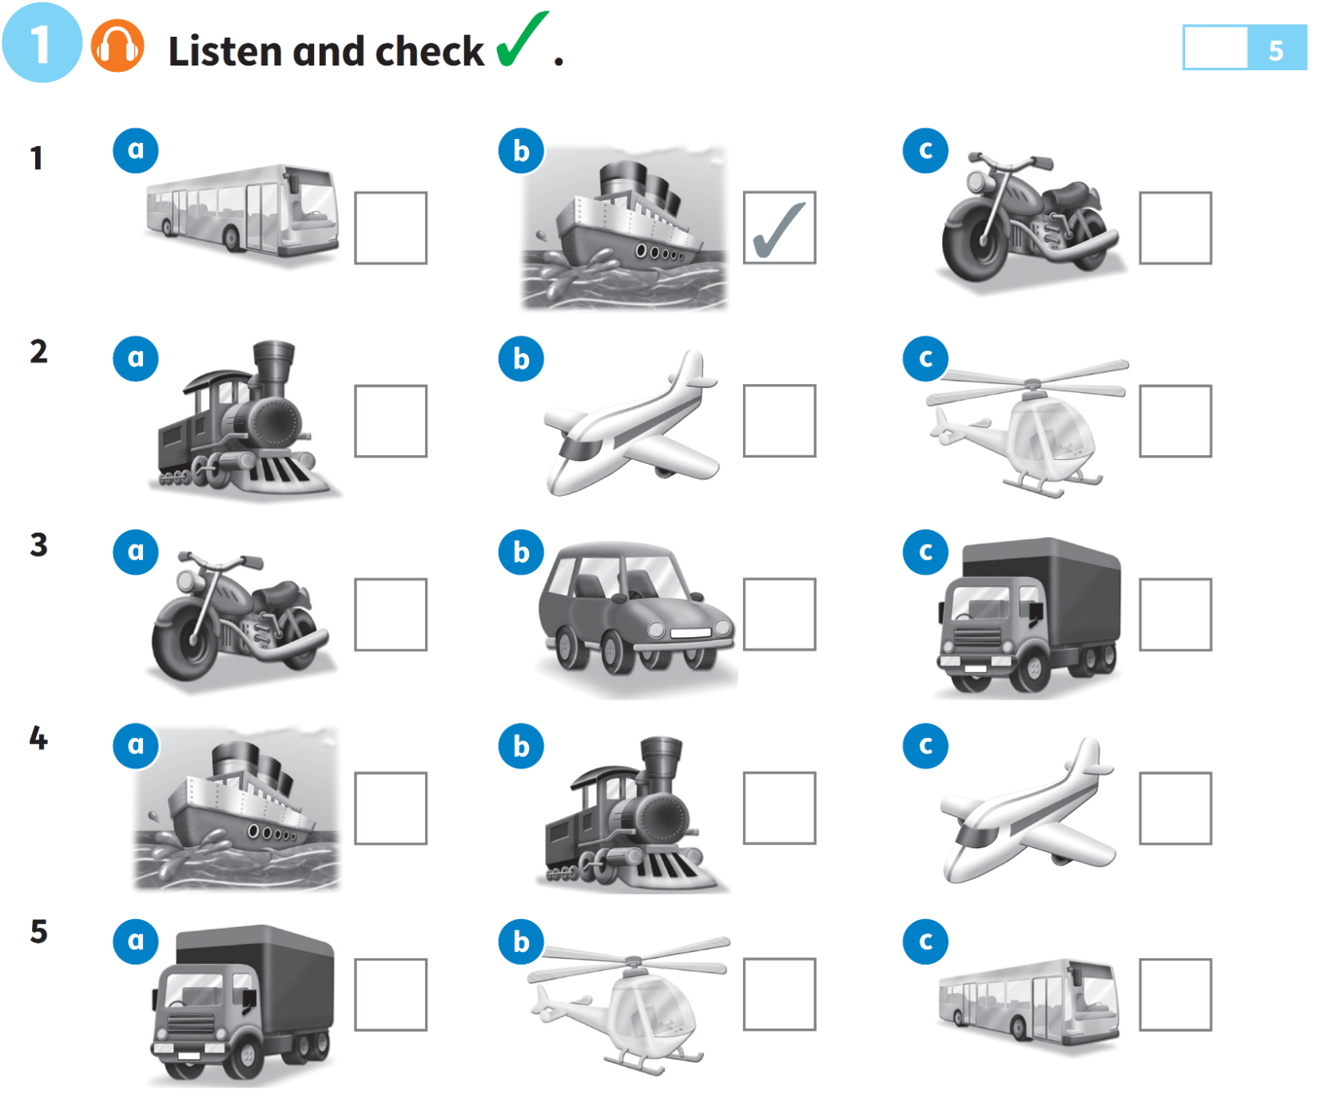**EXAM 2**

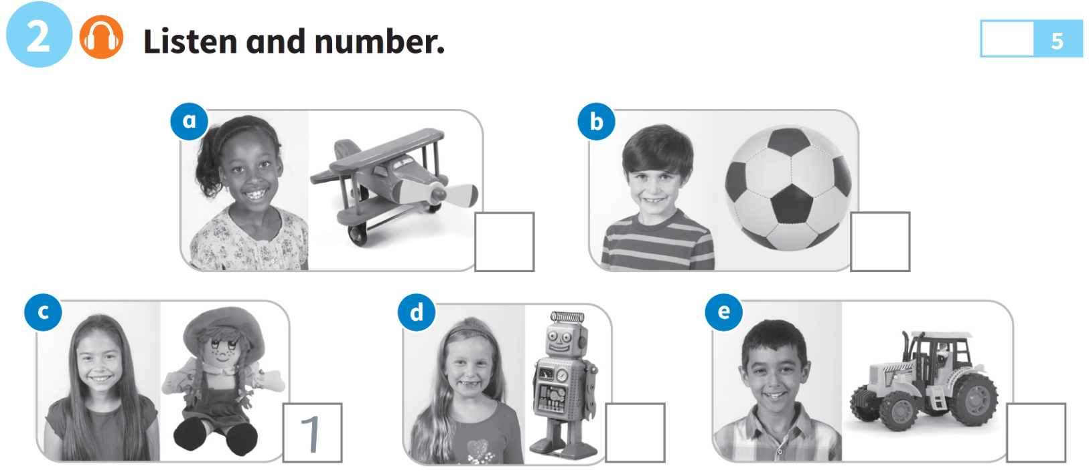

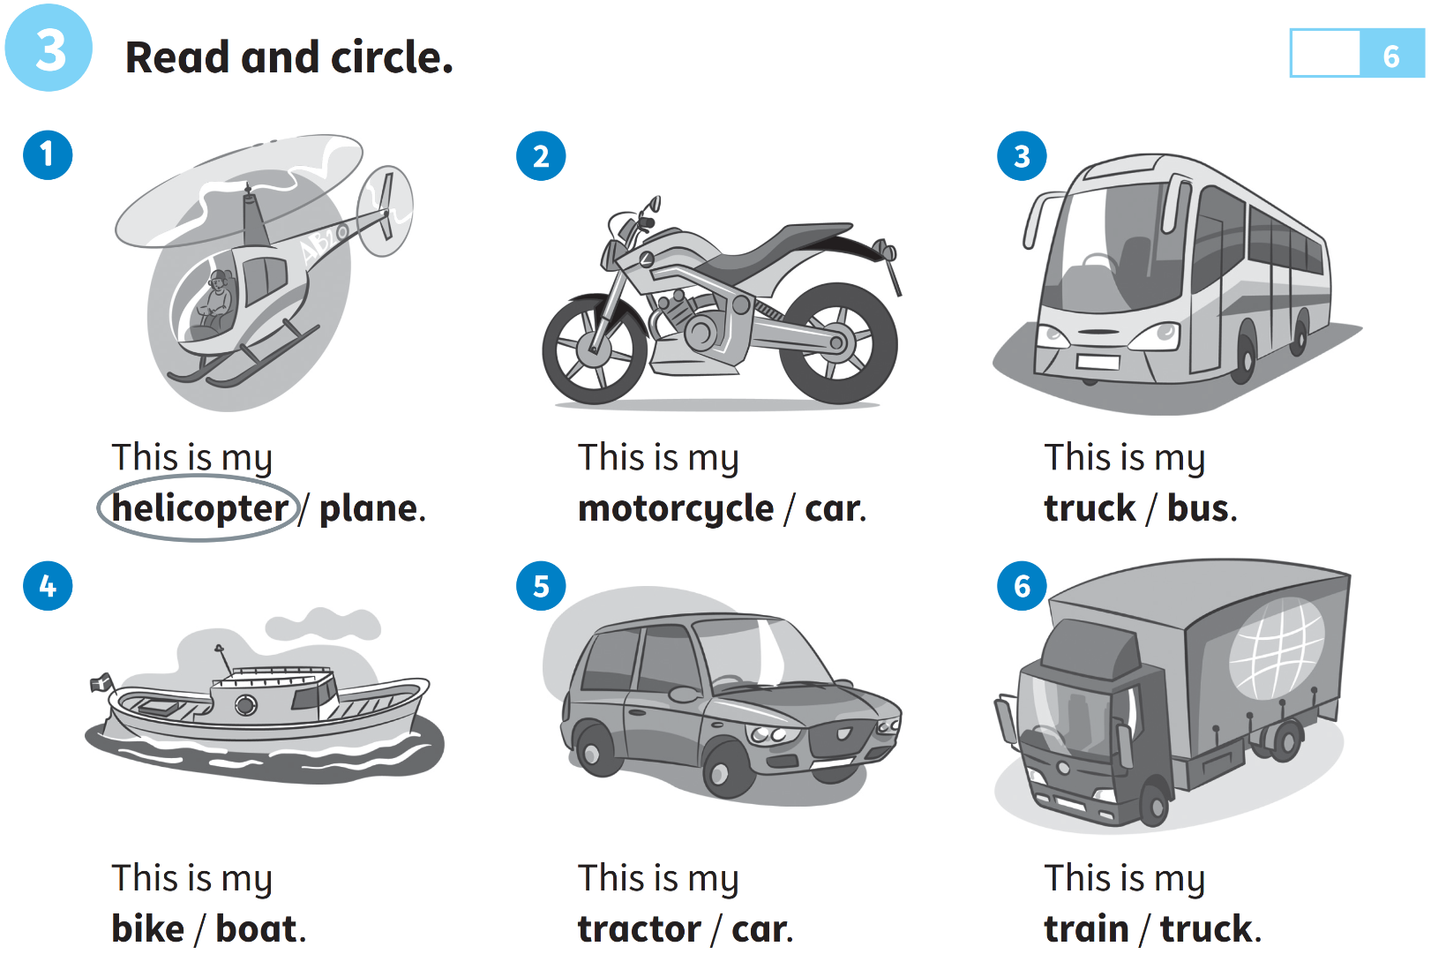

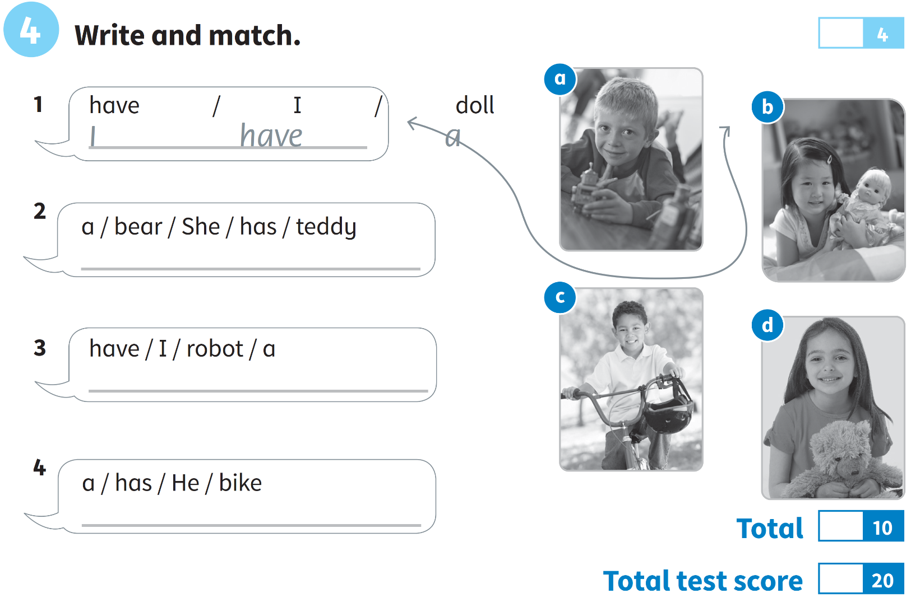

***Date: _______________***

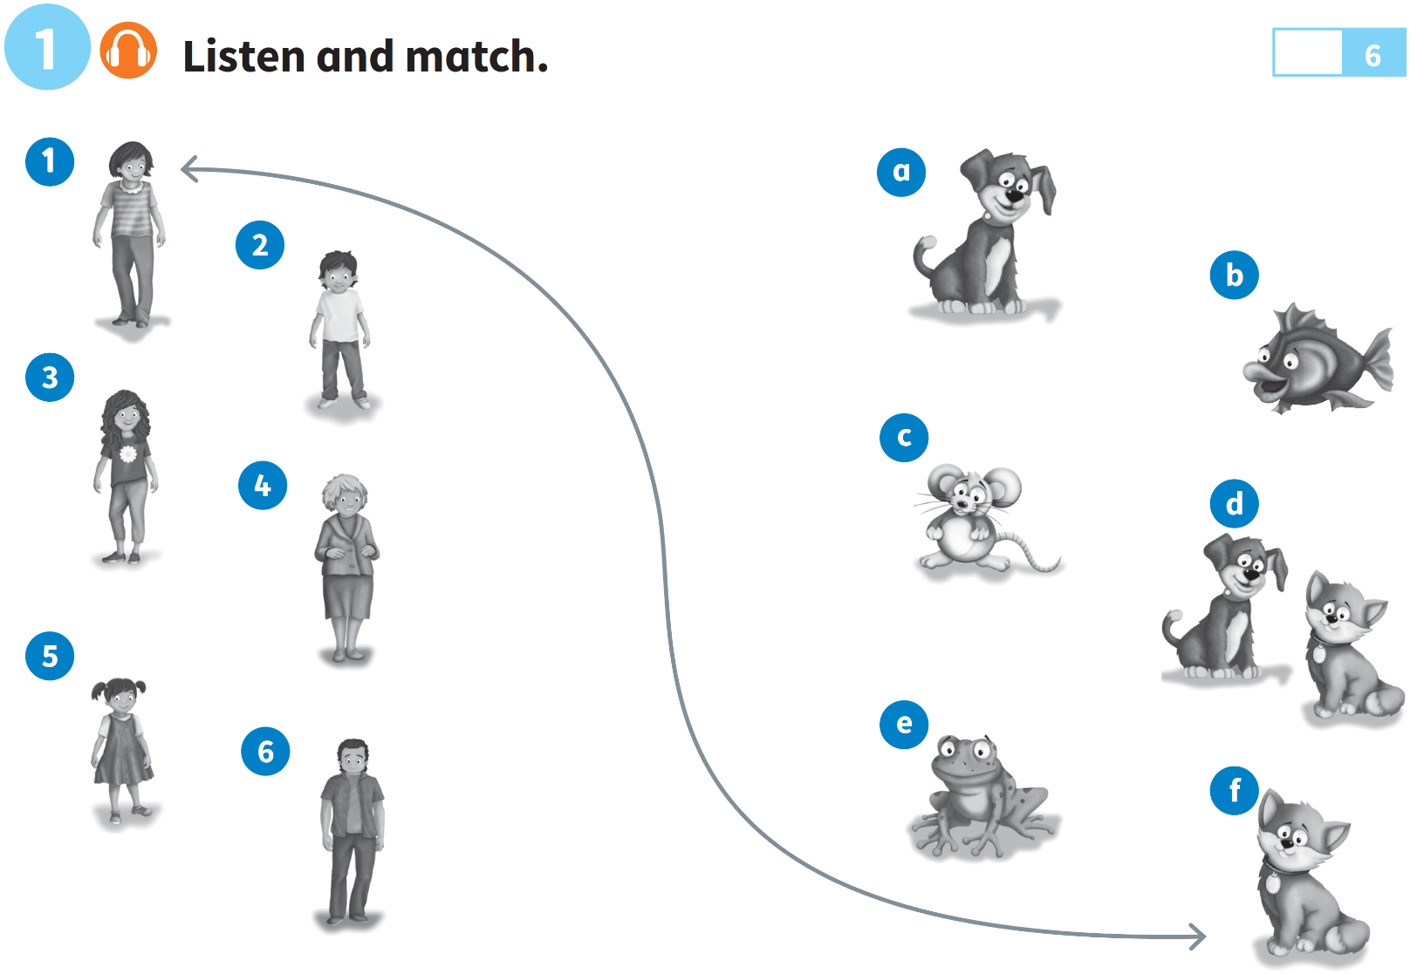**EXAM 3**

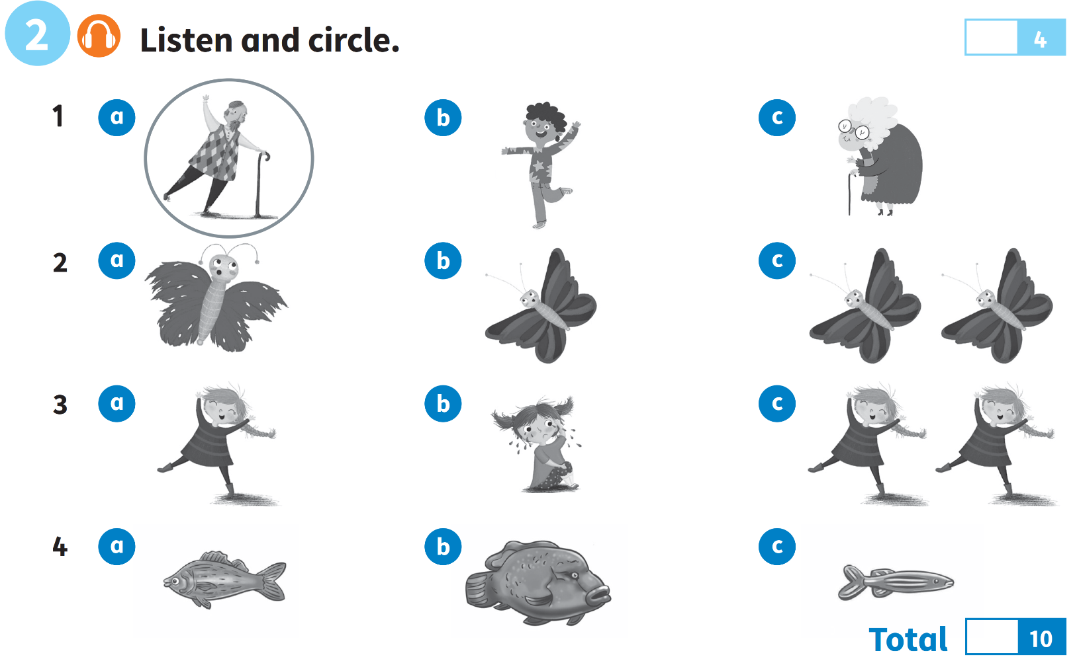

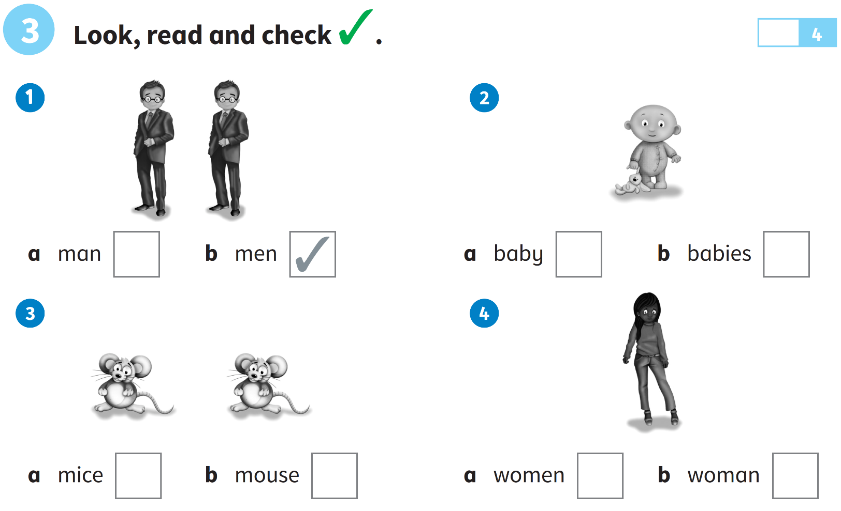

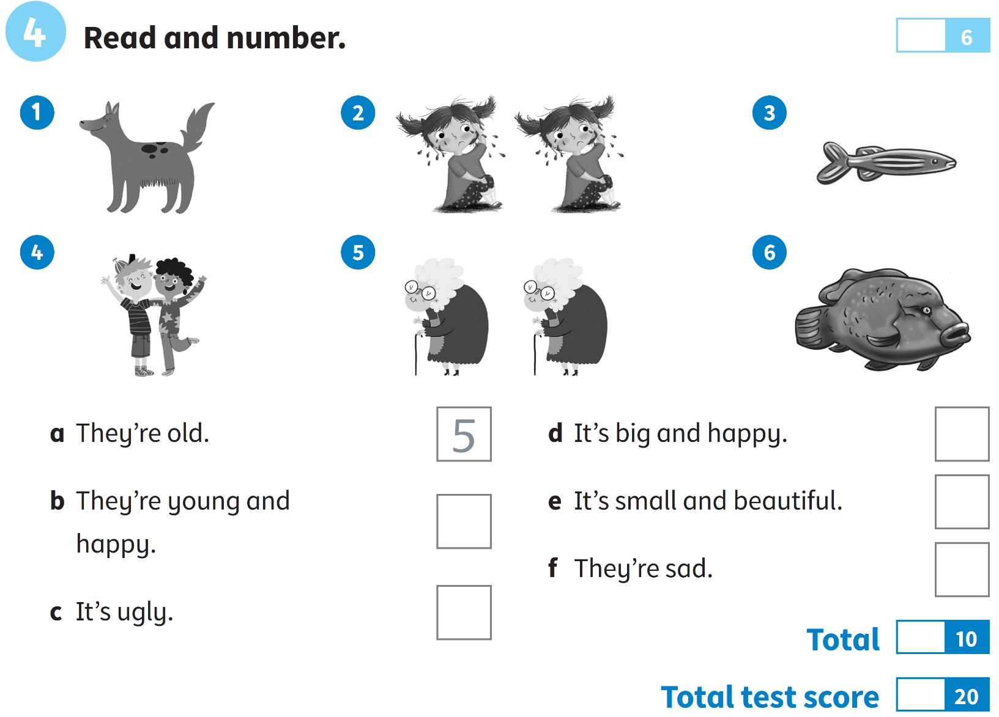

***Date: _______________***

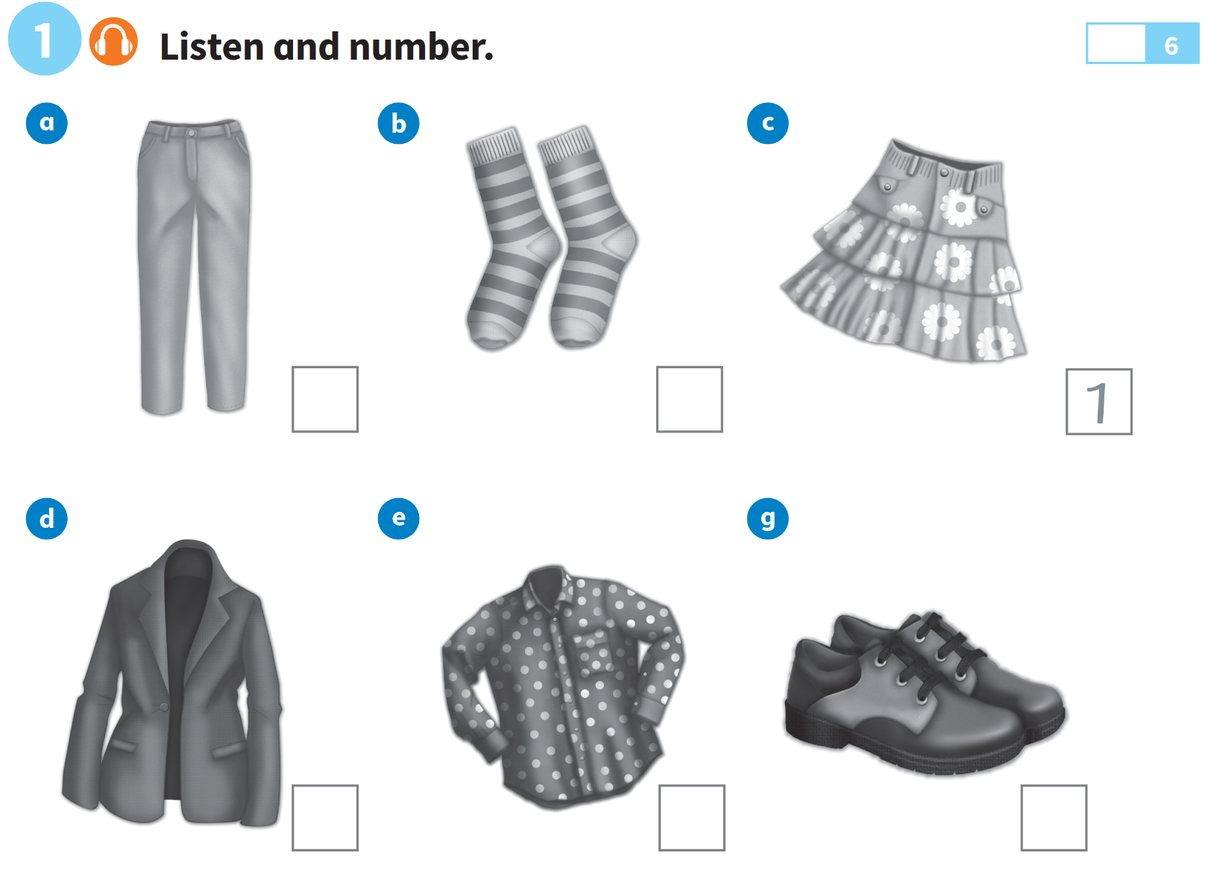**EXAM 4**

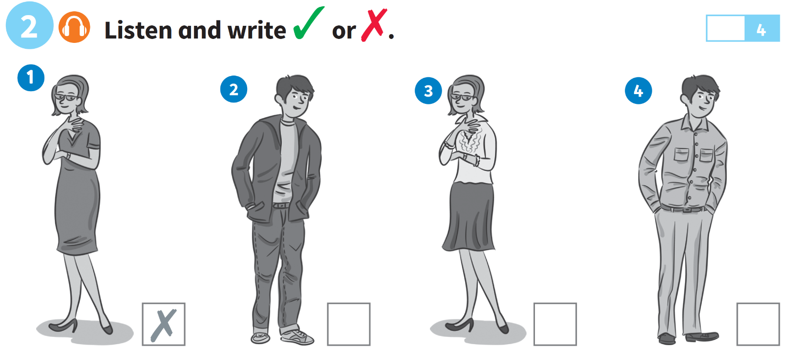



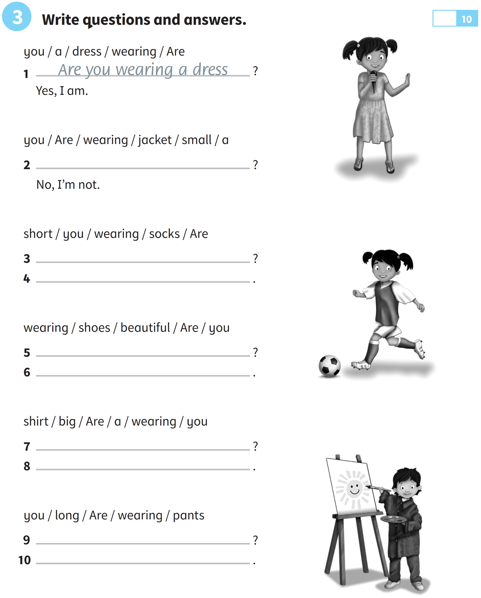

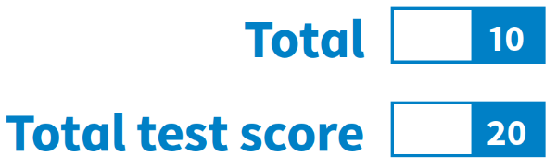

***Date: _______________***

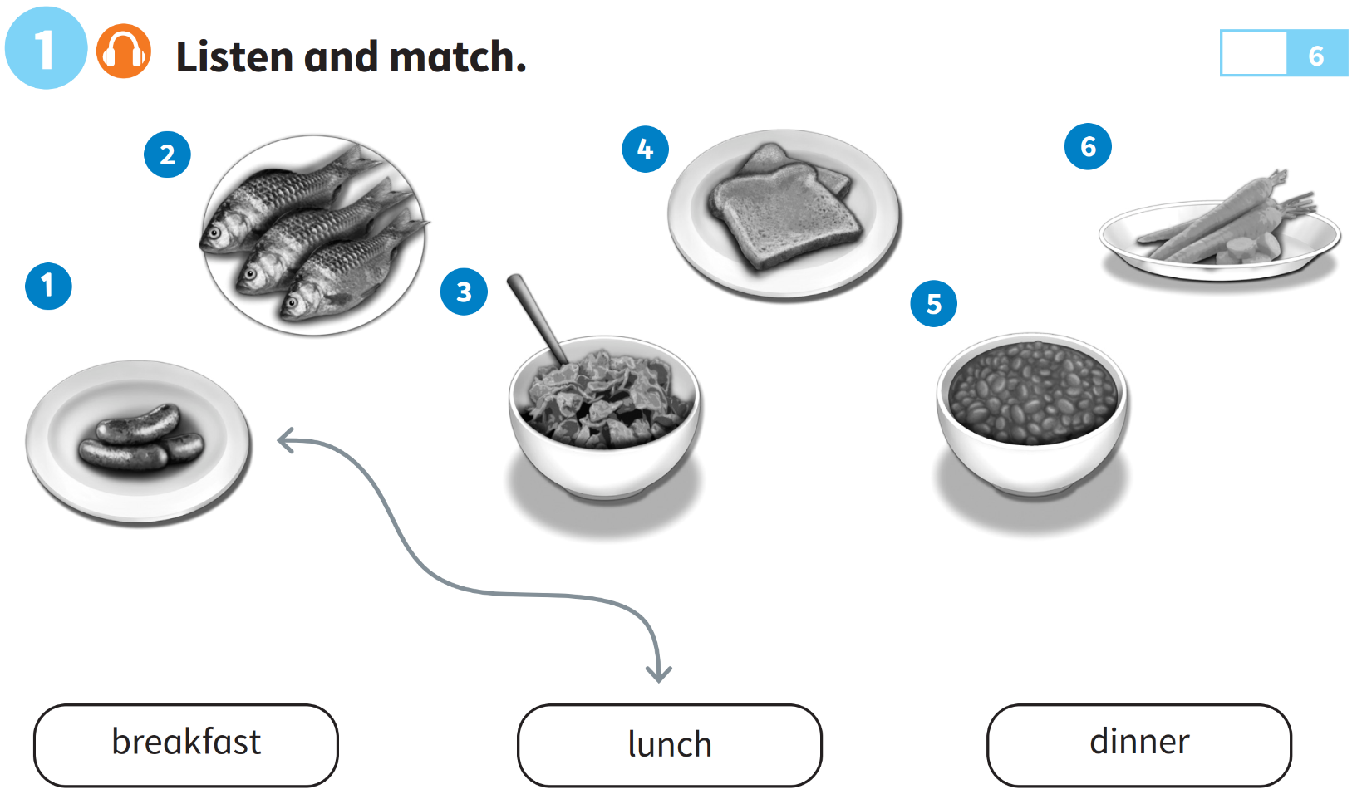**EXAM 5**

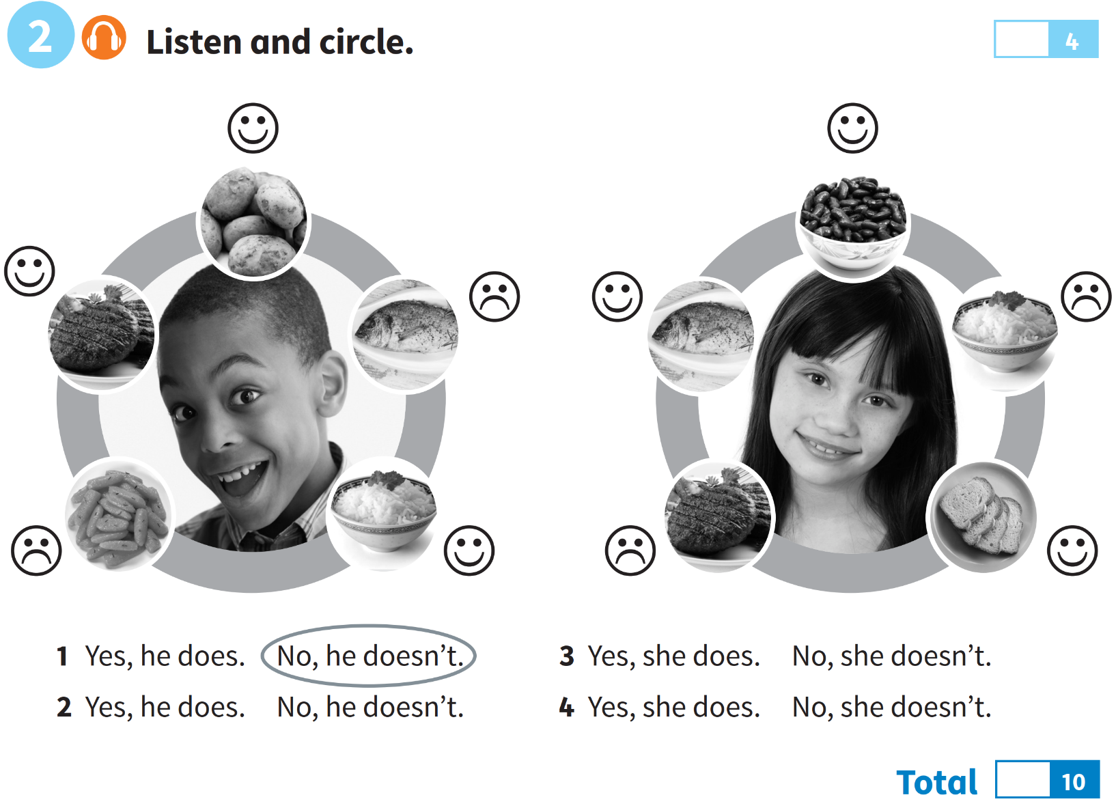

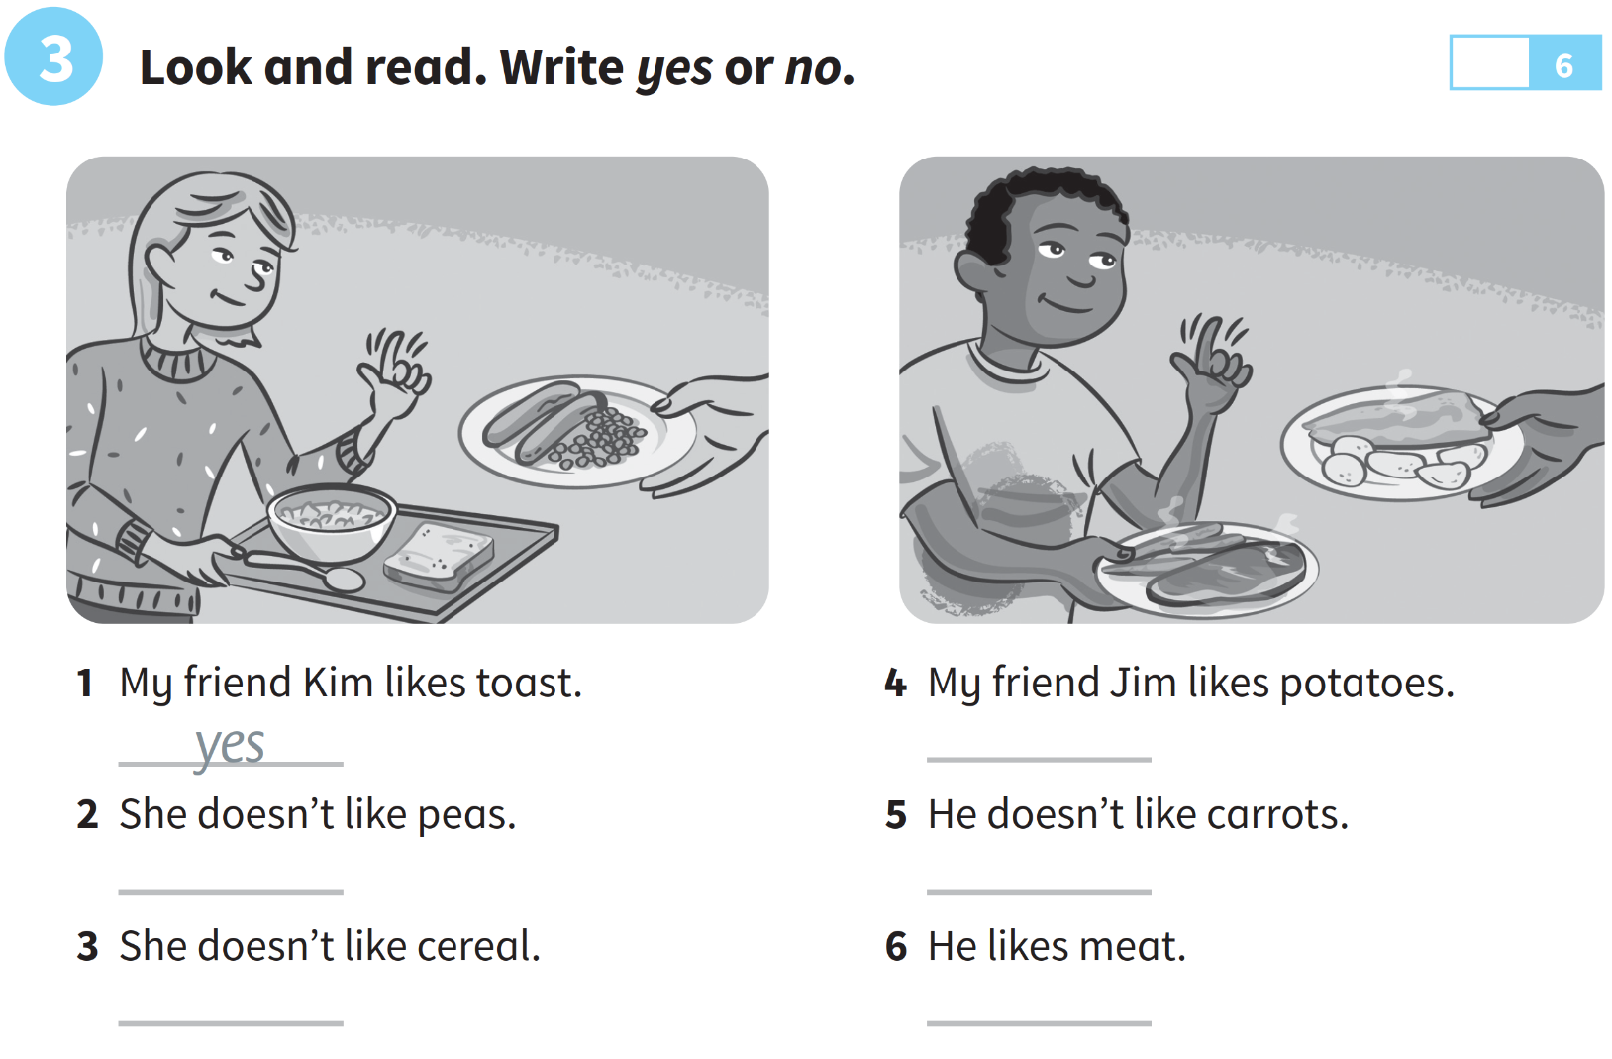

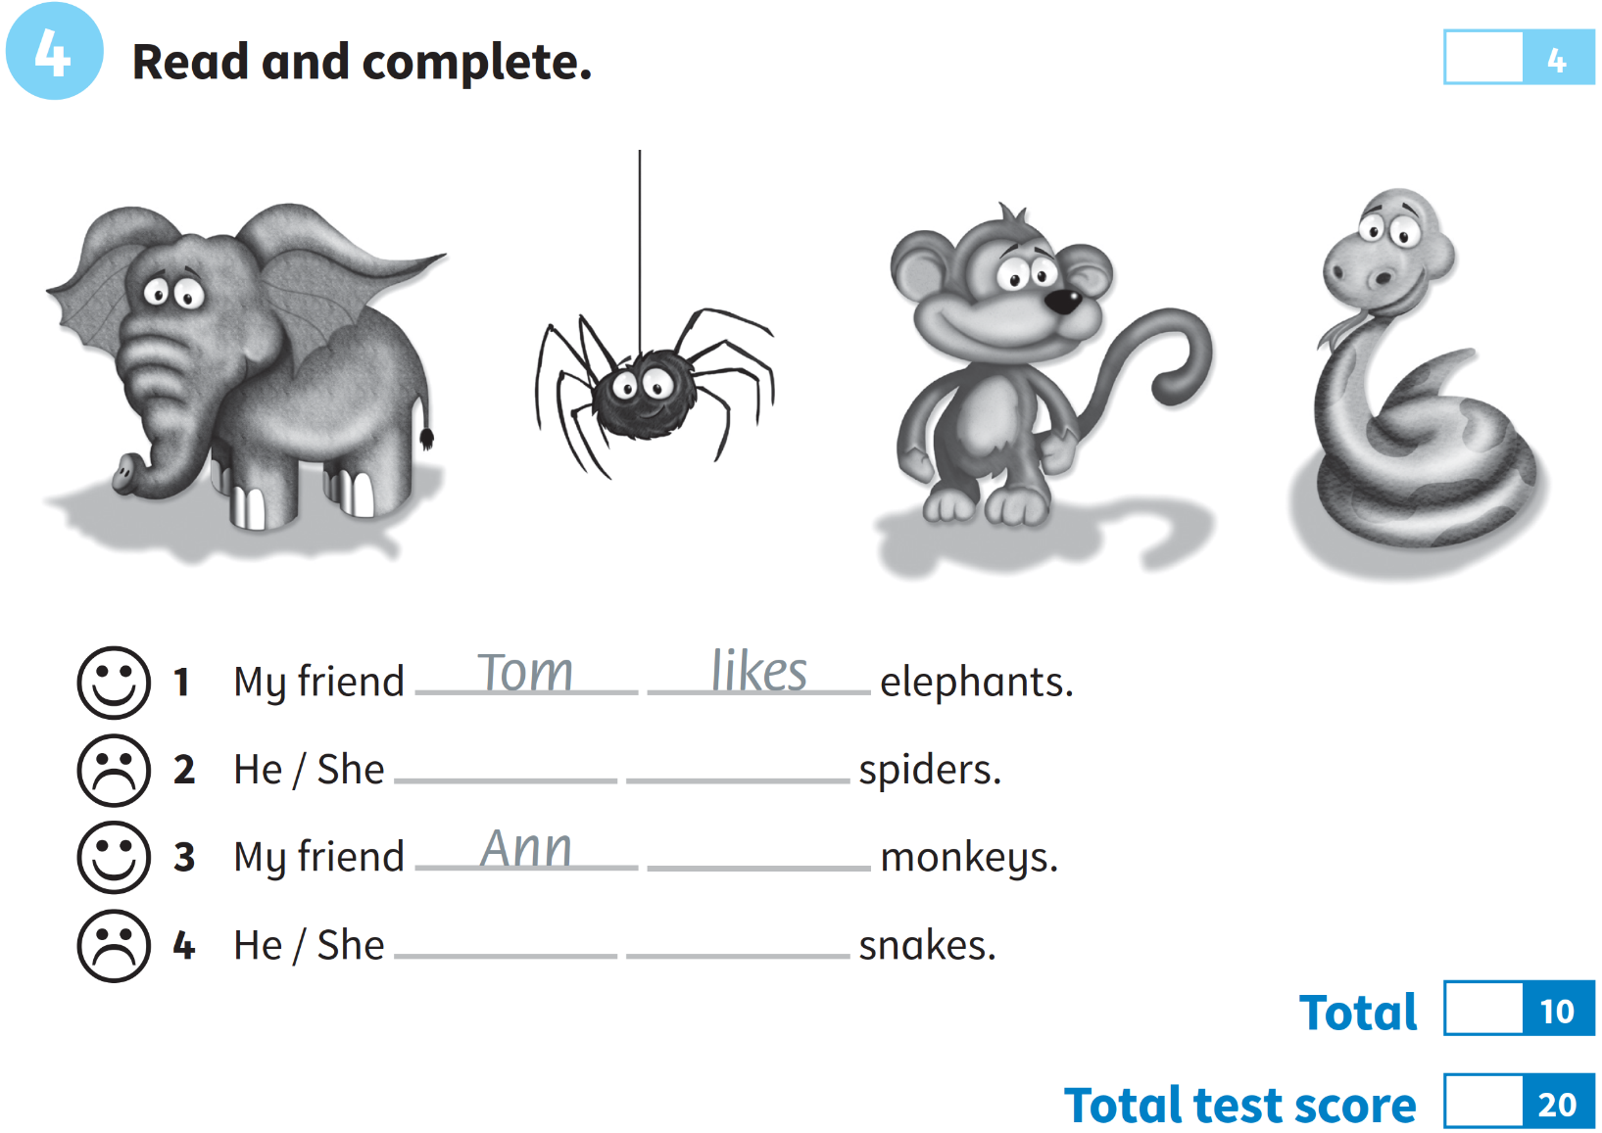

***Date: _______________***

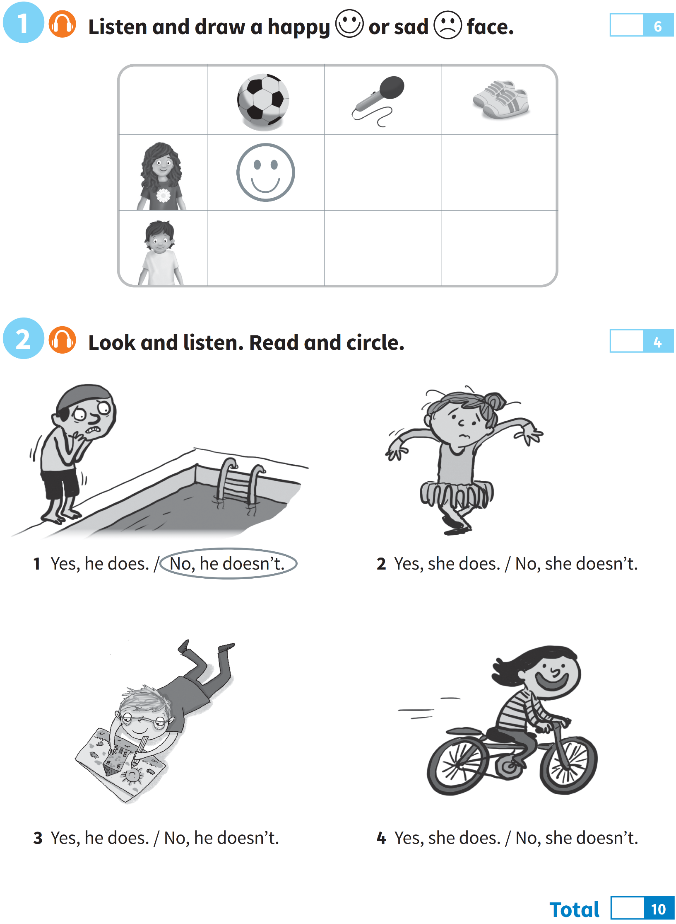**EXAM 6**

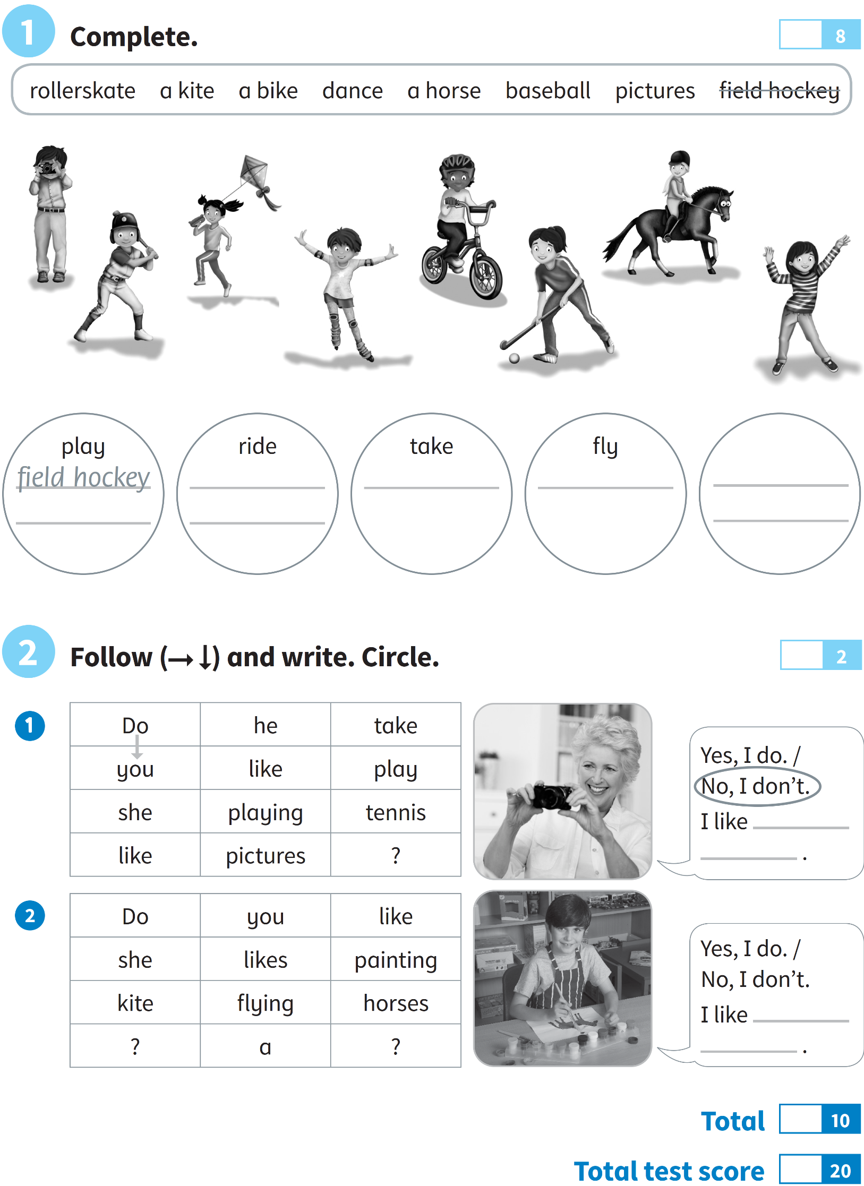

***Date: _______________***

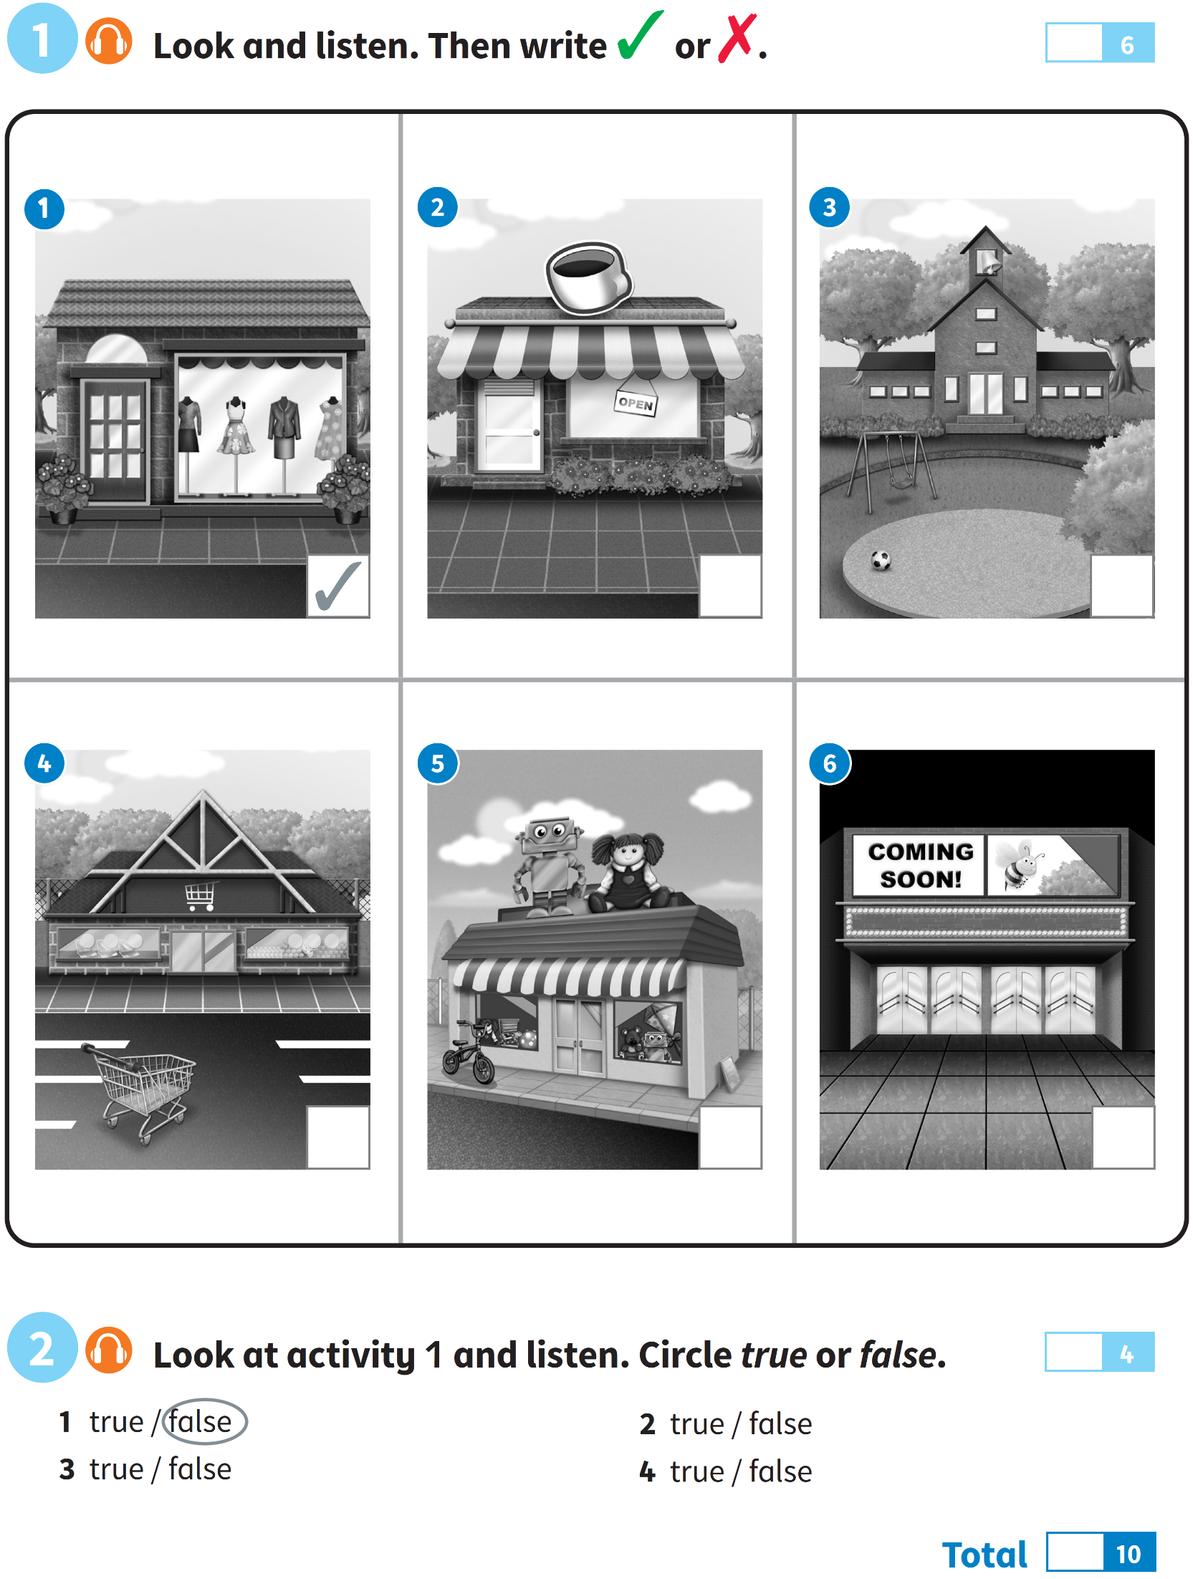**EXAM 7**

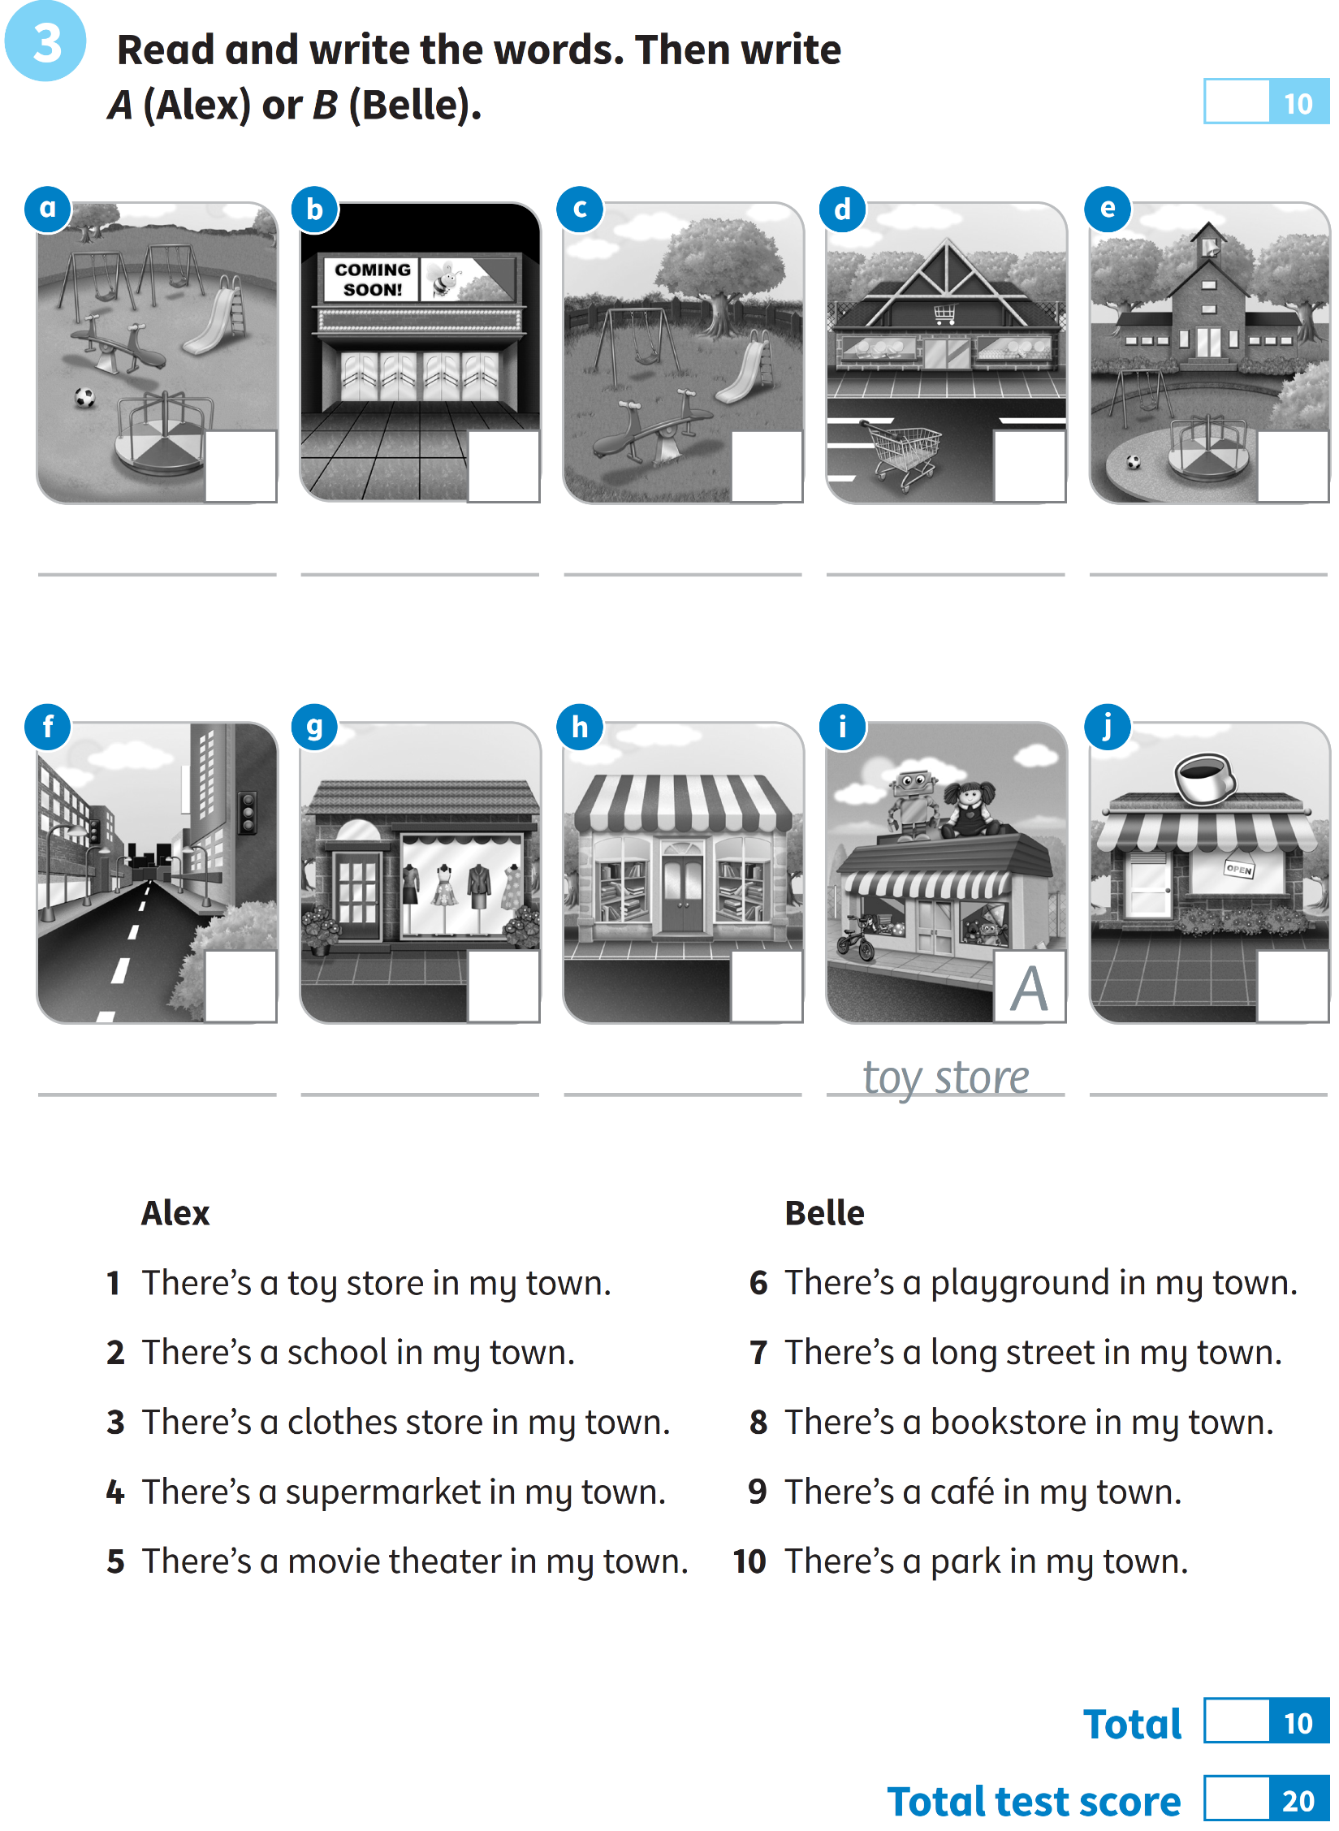

***Date: _______________***

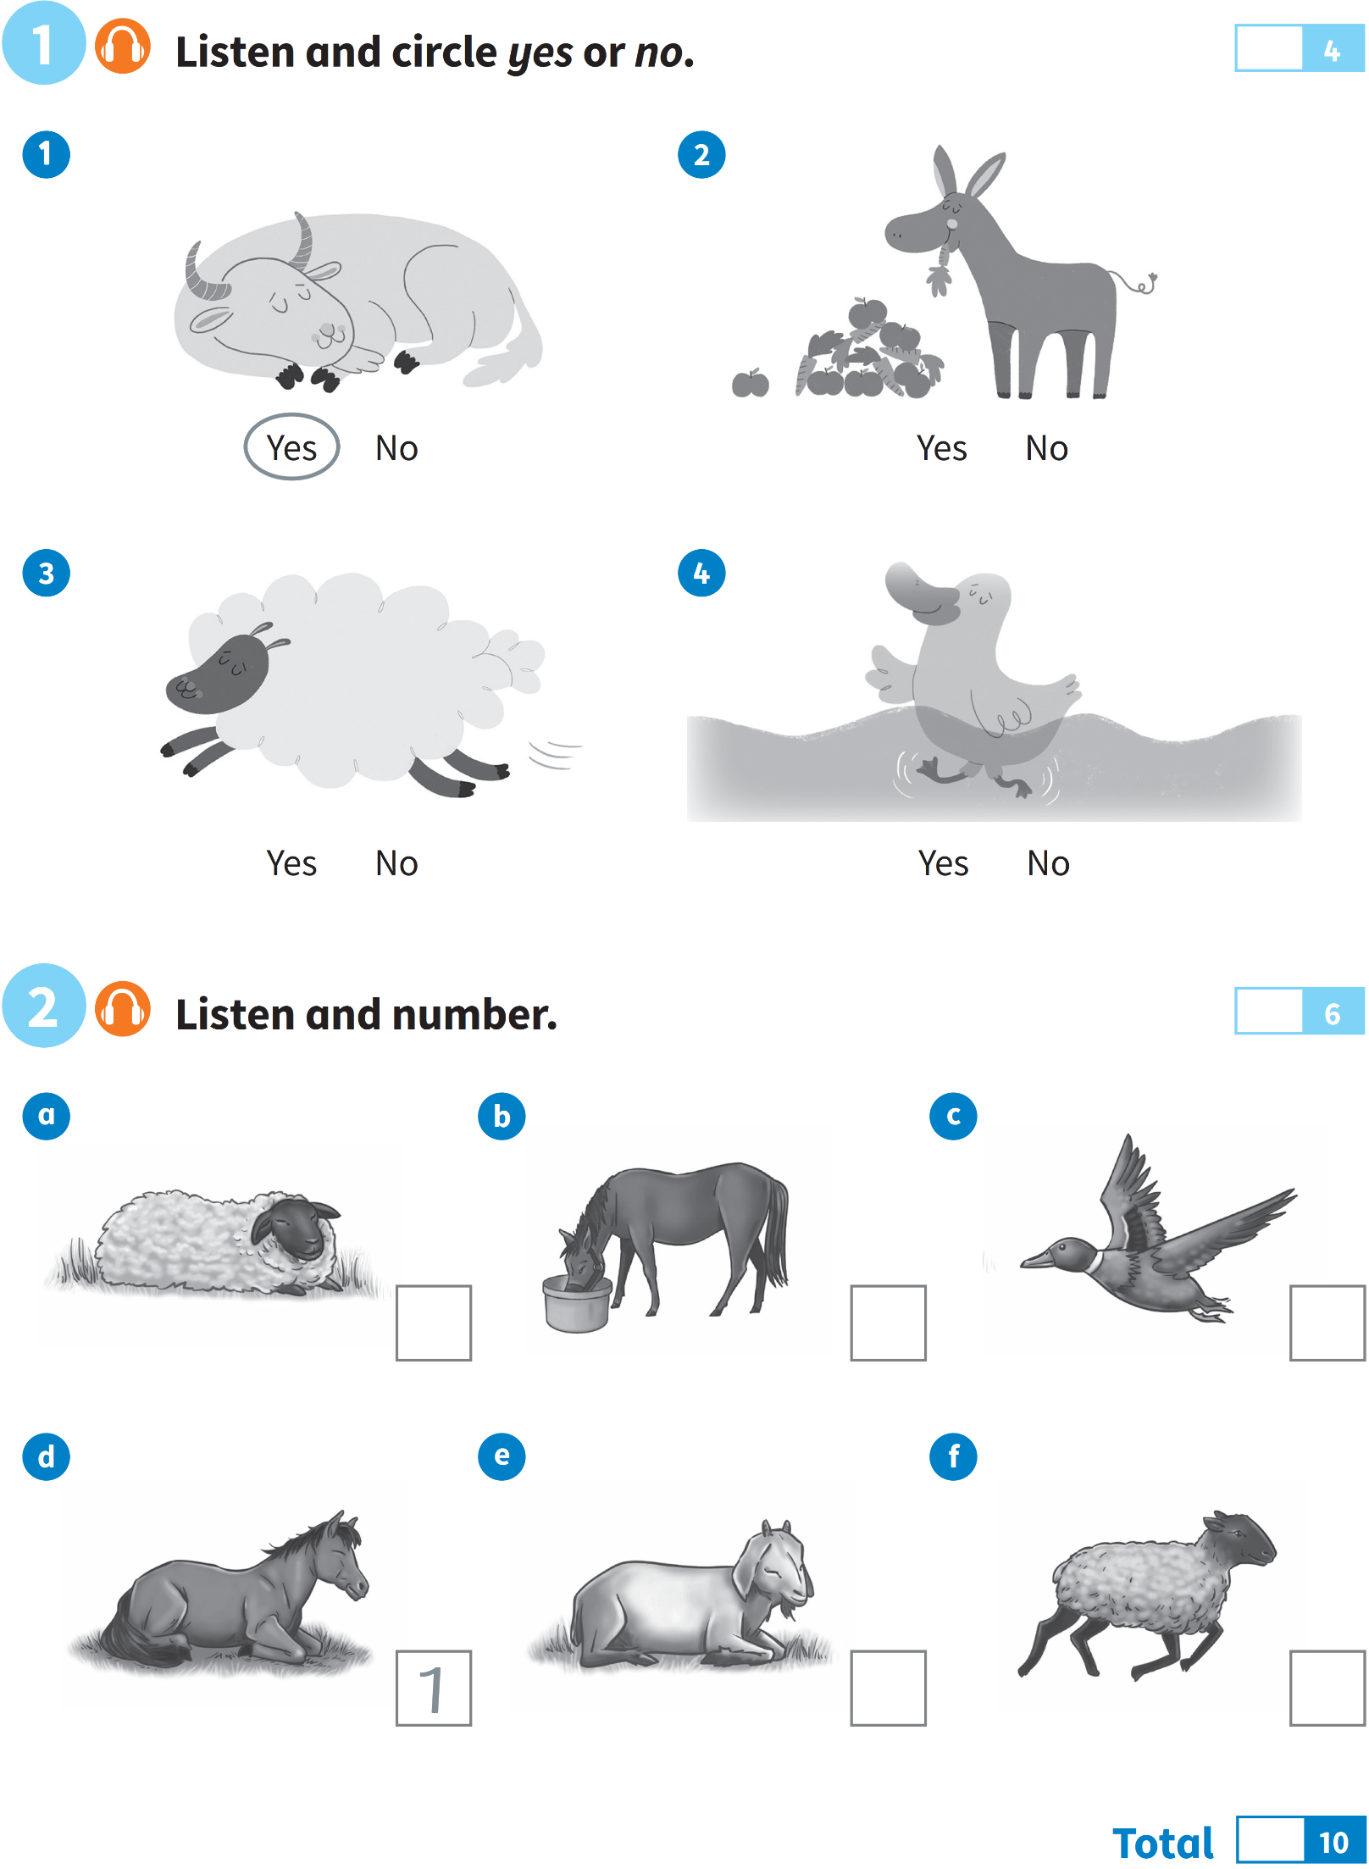**EXAM 8**

